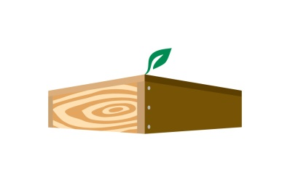
JFR/WSWP Quarterly Newsletter

Our Vision: We are a leader in our industry, we promote conservation and sustainable practices, and we are stewards of our community.

Our Mission: We proudly use wood, a naturally renewable resource, to build value‐added, durable and cost‐effective products ensuring long‐term customer relationships for more than 160 years.

Core Value of the Quarter:

Ownership – We take ownership. We take personal responsibility for the needs of our business, and accept accountability for our results. We don’t make excuses. If we see it, we own it, and make sure it gets done.

Customer Satisfaction Survey Key Points
In a recent customer satisfaction survey, these factors rated highest among JFR/WSWP: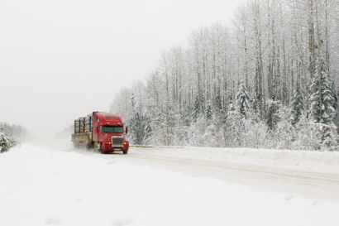

- Customer Service
- Quality/Dependability
- Price

Also reflected in the survey, 3 words most often used to describe JFR/WSWP:
- Professional
- Friendly
- Dependable

Fun Fact: “95% of people text things they could never say in person.”

Ownership Quotes:
“The man who passes the sentence should swing the sword. If you would take a man's life, you owe it to him to look into his eyes and hear his final words. And if you cannot bear to do that, then perhaps the man does not deserve to die.”
― George R.R. Martin, A Game of Thrones
“Parents can only give good advice or put them on the right paths, but the final forming of a person's character lies in their own hands.”
― Anne Frank
“In the long run, we shape our lives, and we shape ourselves. The process never ends until we die. And the choices we make are ultimately our own responsibility.”
― Eleanor Roosevelt
CEO Corner
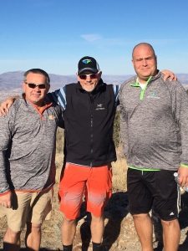
Asking for feedback from customers is essential to our continued success. The real trick is identifying our weaknesses and integrating improvements into our strategic plan. No excuses. We own the issues and take steps to be better!

